First and Second:

Think about relevant political polarization

Also about data collection (we may not collect in all countries)

In-mind magazine

Second day agenda:

Search for papers on polarization and partisan nudge bias and political affiliation and what behavioural policies we want to focus on using connectedpapers

Checking reading

The design, the measures and the country politics

Role division

Things to say on the second day:

What are “nudges” exactly? Do they promote non-deliberative behaviors as opposed to traditional policies like education and informational campaigns that target deliberate processes (Davidai & Shafir, 2020)?

Davidai & Shafir (2020): joint evaluation people prefer traditional; separate settings nudges. Provided with effectiveness information, endorse nudges in joint as well.

Thaler & Sunstein (2008): A nudge is “any aspect of the choice architecture that alters people’s behavior in a predictable way without forbidding any options or significantly changing their economic incentives. To count as a mere nudge, the intervention must be easy and cheap to avoid. Nudges are not mandates. Putting fruit at eye level counts as a nudge. Banning junk food does not”

Bang, Shu & Weber (2020): disclosing that a choice architecture design is in place doesn’t reduce its effectiveness. People think certain designs affect others more than themselves. Perceived effect on self increases if the person has experienced the design. Intentions of the source matter more than who the source actually is.

Bruns et. al. (2018): Same thing as Bang et al (2020), We test how different types of transparency (i.e. knowledge of the potential influence of the default, its purpose, or both) influence the effect of the default. Our findings demonstrate that the default increases contributions, and information on the potential influence combined with the purpose of the default, or just its purpose, do not significantly affect contributions. Findings are somewhat inconclusive with respect to information on the potential behavioral influence. Furthermore, we do not find evidence that psychological reactance interrelates with the influence of transparency.

Stoffel et. al. (2019): Explored decoy effect in intention to get a screening test in a target or decoy hospital (weak/strong decoys). Limitation is that there was behavioural confirmation.

Hertwing & Grune-Yanoff (2017): Nudges vs Boosts (a) their immediate intervention targets, (b) their roots in different research programs, (c) the causal pathways through which they affect behavior, (d) their assumptions about human cognitive architecture, (e) the reversibility of their effects, (f) their programmatic ambitions, and (g) their normative implications

Grune-Yanoff & Hertwing (2015): examines the policy–theory coherence of nudges vs boosts

Hansen (2016): Defines Libertarian paternalism and nudges by returning to its foundation in behavioural economics

Gigerenzer (2015): Nudge research suffers from narrow logical norms, that is, a misunderstanding of the nature of rational thinking, and from a confirmation bias, that is, selective reporting of research.

Choice Architecture: This term coined by Thaler and Sunstein (2008) refers to the practice of influencing choice by “organizing the context in which people make decisions” (Thaler et al., 2013, p. 428; see also nudge). A frequently mentioned example is how food is displayed in cafeterias, where offering healthy food at the beginning of the line or at eye level can contribute to healthier choices. Choice architecture includes many other behavioral tools that affect decisions, such as defaults, framing, or decoy options.

Defaults: Default options are pre-set courses of action that take effect if nothing is specified by the decision maker (Thaler & Sunstein, 2008), and setting defaults is an effective nudge when there is inertia or uncertainty in decision making (Samson, 2014). Powerful when there’s inaction, perceived as recommended course of action when difficult

Framing: Choices can be presented in a way that highlights the positive or negative aspects of the same decision, leading to changes in their relative attractiveness. The concept of framing also has a long history in political communication, where it refers to the informational emphasis a communicator chooses to place in a particular message. In this domain, research has considered how framing affects public opinions of political candidates, policies, or broader issues (Busby et al., 2018).

Decoys: Choices often occur relative to what is on offer rather than based on absolute preferences. The decoy effect is technically known as an ‘asymmetrically dominated choice’ and occurs when people’s preference for one option over another changes as a result of adding a third (similar but less attractive) option. For example, people are more likely to choose an elegant pen over $6 in cash if there is a third option in the form of a less elegant pen (Bateman et al., 2008). While this effect has been extensively studied in relation to consumer products, it has also been found in employee selection (e.g. Slaughter et al., 2006), apartment choices (Simonson, 1989), or as a nudge to increase cancer screening (Stoffel et al., 2019).

What countries should we consider? UK and Slovenia (practical reasons)

Kellen in our meeting!: [km2188@bath.ac.uk](mailto:km2188@bath.ac.uk) – [vanboven@colorado.edu](mailto:vanboven@colorado.edu)

Sorting mostly for social issues – Former policymakers (easier to get them) – Contacts for policymakers – capturing uncertainty

Possible social policies:

Easing immigration forms – canteen serving kosher and halal foods – encouraging stores to place pride materials (rainbow flags etc) on the front rows during pride month – diversification bias (veggies and fruits) – abortion – military – affirmative action – feminism – colonialism – trans rights

Possible roles: one formal role (communications officer) – project coordinators – data management and analysis (using R and SPSS mostly, but stuff like JASP works as well, we’ll also have some material for R coding) – study design

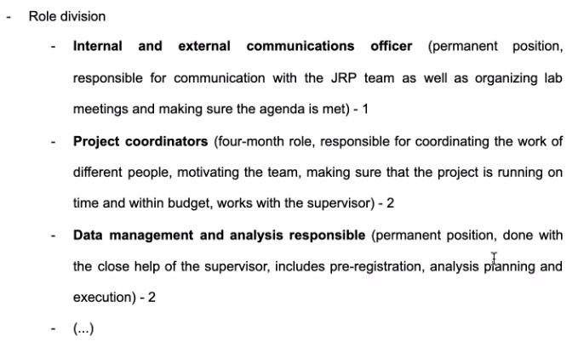

Third day agenda:

Look for meta-analyses, review articles, and such about nudges

Google searches regarding nudges in annual reports of major organization

The behavioural policies we would like to include (conceptual)

Look for funding: psychology associations and societies (small grants) – Universities and college funding – student association – we can actually get grants for international research

Third day:

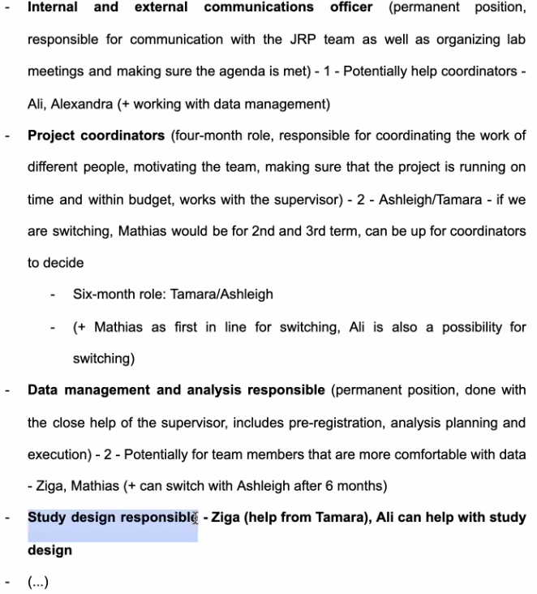

Different social policies:

SIMPLER (the UN document)

Reminders (text messages and such) – Norm-based interventions (statistics showing the timeliness of conscientious individuals paying their tax on time and that the individual was not part of this group as they had failed to pay on time) – public good statements (sort of an informational campaign, illustrated the beneficial public services the individual would have access to if taxes were paid on time and the poor social outcomes that could happen if the individual did not pay tax on time) – easing the restrictions / availability (provided low-cost labor to clear them) – City planning and architectural choices (In Singapore, the Ethnic Integration Policy attempt to promote a mix of all races within each subsidized housing district in order to foster social and racial cohesion while providing citizens with affordable housing.) – Diversification nudge (regarding healthy/unhealthy food – vegan options – traditional cuisines/) – color manipulations – increasing/decreasing bureaucratic sludges

We’re working on the miro board right now, and have defined nudges and now it’s time for their non-partisan definitions.

Examples are hard :((((((

Alumni chat: conservative friends, checking newspapers, party programs, and such, doing a pre-study

Niklas Cypris ([nfc@posteo.de](mailto:nfc@posteo.de))

Day 4:

Defaults: Behavioural scientists have found out that one way of steering people towards certain behaviours and choices is utilizing default options. When an option is selected as the default, people are more likely to remain with that option as opposed to easily changing it to another option. It is important to note that opting out of the default option is easy and without cost.

Control example: A healthier dietary balance will benefit most people. By setting healthy foods as the default option in online food ordering platforms, it is possible to increase healthy consumption and reduce unhealthy food intake.

Liberal example: In severe cases of illness or accidents, victims are sometimes in need of organ donation from other people. By making organ donation the default option which people can opt out of if they wish, the rates of donation can be significantly increased.

Conservative example: To strengthen the armed forces, it is necessary to invest in military training of the people. By setting aside a portion of the residents’ tax money for training recruitment campaign by default, it is possible to voluntarily train a greater number of people. This option of spending can be opted out of by the residents if they wish.

Decoys: The Decoy Effect occurs when people’s choice in a two-option decision is changed by adding a third option that’s wholly inferior to one option, but inferior and superior in some aspects to the other option.

Control example: when presenting people with an ornate-looking pen and 3$, most people will choose the money. But if a plain-looking pen is added to the selection, people are more likely to pick the ornate-looking pen.

Liberal example:

Inclusion/exclusion (over 18, Citizenship and residency, language) – recruitment (facebook groups, police academies, conservative student unions and associations, subreddits, Prolific if we’re severely lacking in conservative participants) – self-report measures (SES ladder, income, ethnicity, employment, occupation, education level)(questions about policymaking: which office do you work at, what sector, questions about the example itself)(feedback for study hypotheses and purposes)

More nudges in the pilot, ask people about how diagnostic and political the nudges are, ask them about the general understanding of the study, having a baseline for control conditions, present them in blocks of the control condition and then a random example,

Consider breakpoints, for example when we have enough participants from a country or political attitude

Day 5 agenda:

Abstract (120 words) – presentation

Day 5

Discussing project timeline

Ethics during the summer

Creating the stimuli

The pre-registration

Kai meeting: how to increase chances of getting accepted into a good university, how to find out the specifics about a universities specialization (insider’s view), Fundings for PhDs and Master’s

Look up studies author and their institution – follow recent publications

PhDs are usually funded, international students usually get some funding, DO NOT BRING UP FUNDING FIRST WHEN APPLYING FIRST MAKE SURE THEY’RE A GOOD FIT

Presentation aims:

To explore actual and perceived polarization toward nudges among general public.

To explore perceived polarization toward nudges among policymakers.

To explore how the general public and policymakers of different political affiliations perceive political divides in the domain of nudges.

To explore the public’s attitudes across different national context to behavioural policy interventions.

PhD airtime: Ashleigh - Yes! Some funding applications come earlier than programme applications (but then your funding offer becomes conditional on your acceptance to the programme)

in the Netherlands vacancies pop up all year round and you can apply when you are still doing your masters (but check if the starting data is in line with you finishing the masters)

Sofia - In Italy calls open around April, you do not NEED to have a diploma but it is highly recommended, because many people apply for PhD

Tailor the research proposal and don’t send a 100% same

Concerning GPA: Are you expected to have a perfect GPA from b.sc and m.sc or are other aspects of your application more important and a good GPA is just a bonus but not an aspect on which your entire application hinges?

Yes, Sofia, it doesn’t have to align 100% with previous research, but you need to really demonstrate motivation for the topic then! Far from impossible - I know people who got PhDs on topics they didn’t work on previously

for me the research topic was in line with my working experience (but not research experience) - but a lot of this is also how you frame it!

oh! an extra question: did you all have publications prior to your applications for PhD positions? No publications, but I presented some conferences/posters / I did already have publications and would say that it helped to get the position, but other PhD's in my department did not have prior publications. I think the main thing is showing your affinity with research / Melika: nope, just conferences and some in prep manuscripts / Publications definitely help, but are not necessary to be accepted to the programme (I had one submitted paper at the time of applying only)

I had a question: is it possible to apply for multiple partial funding options for a PhD? Usually yes, but not in the case of full funds (can be negotiated though, for research costs)

Nina Vyvcharuk

To

Everyone

1:53:25 PM

for the Netherlands, is it crucial to do a research master to later go into PhD?

Sanne Verra

To

Everyone

1:53:42 PM

research master is beneficial for PhD but not necessary

Nina: I thought so too and that’s why I was hesitant to apply! But definitely not a requirement!

Melika Miralem

To

Everyone

did anyone of you need to submit any letters of recommendation for PhD? I expected that this plays a huge role in the process of applying, 'cause that was super important for my master's for instance

Mekiš Recek, Žiga

To

Everyone

how important is it from which university you come from (like the reputation etc.)?

Sanne Verra

To

Everyone

I actually don't remember if a letter of recommendation was required or not, but generally i totally recommend to hand in those letters anyway - even if you have to merge your pdfs to get it in there!

Bojana Veckalov

To

Everyone

1:56:48 PM

Melika: no, just names of referees. Then supervisor can contact them if they want. But this is also highly specific for the programme

Jelka Stojanov

To

Everyone

In my case, 3 referees needed to submit letters as a part of the application

silvia.filippi.1@studenti.unipd.it

To

Everyone

In Italy they ask for two recommendation letters and it’s pretty important to have them

Mathias AndersenToEveryone

2:01:39 PM

What do you think would preferred in the application proces: Having a MSc in Psychology with experience in research of the specific research topic or having a MA in Psychology with a higher GPA.

silvia.filippi.1@studenti.unipd.itToEveryone

2:02:13 PM

Mathias - first option, for sure!

Jelka StojanovToEveryone

2:02:22 PM

First option as well:)

Mathias AndersenToEveryone

2:02:46 PM

Thanks :-)

silvia.filippi.1@studenti.unipd.itToEveryone

2:02:53 PM

If you also could have some experience of teaching it helps!

Alexandra SymeonidouToEveryone

If the previous research experience you have is not that closely connected to the phd you wanna apply for is it still considered an “advantage”?

Mathias AndersenToEveryone

Good to hear! Thank you for the answers

Bojana VeckalovToEveryone

Yes, MSc-MA distinction is not that important

F21st July 4pm Rome time –

Send the stuff to Jelka at least one day before – Asking for their position? (high/middle/low with examples) alongside the ministry they are in – if more than one study, and one stimuli depends on the pilot, uni usually gives ethics for the pilot – stimuli piloting after issue piloting – checking parties’ pages based on the yougov score of their liberal/conservativeness

Tasks for next week (15/8): ethics UK form, political party page search, coming up with divisive issues for the issue pilot, stick to the distinction between system 1 and 2 for stimuli, 19th of August